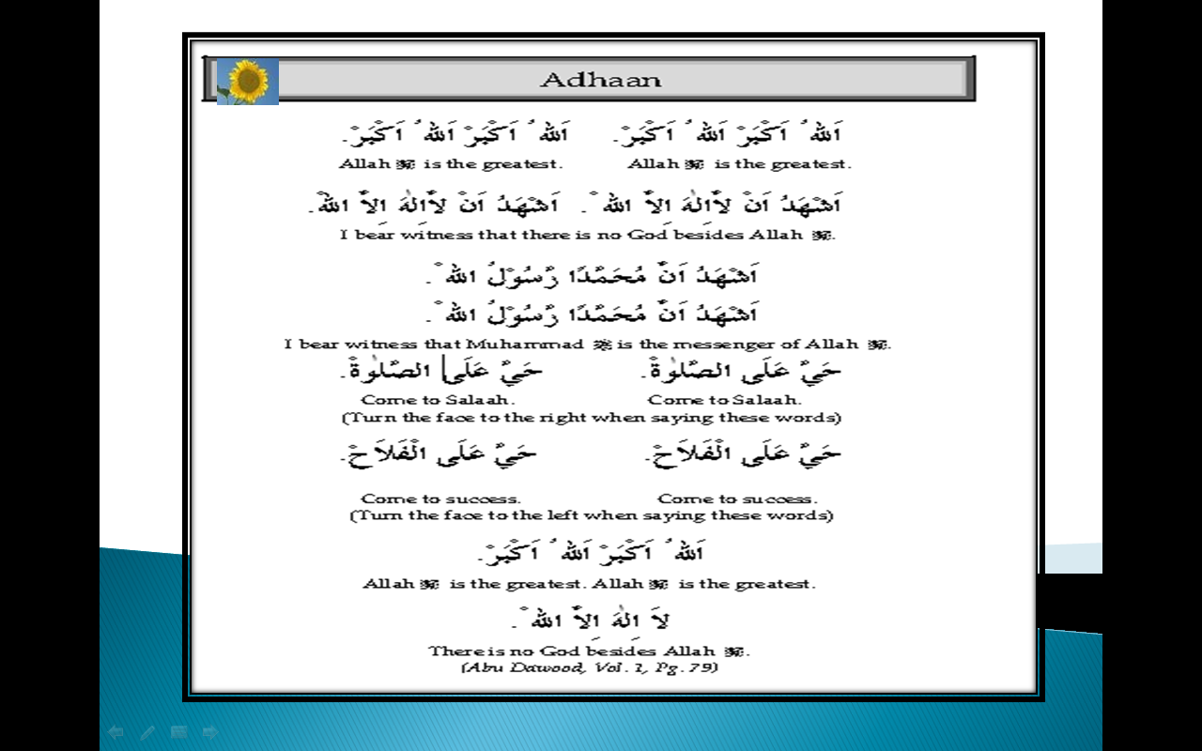
  Write English meanings of Adhaan.

