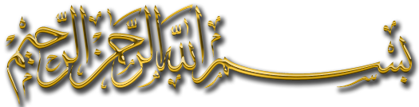
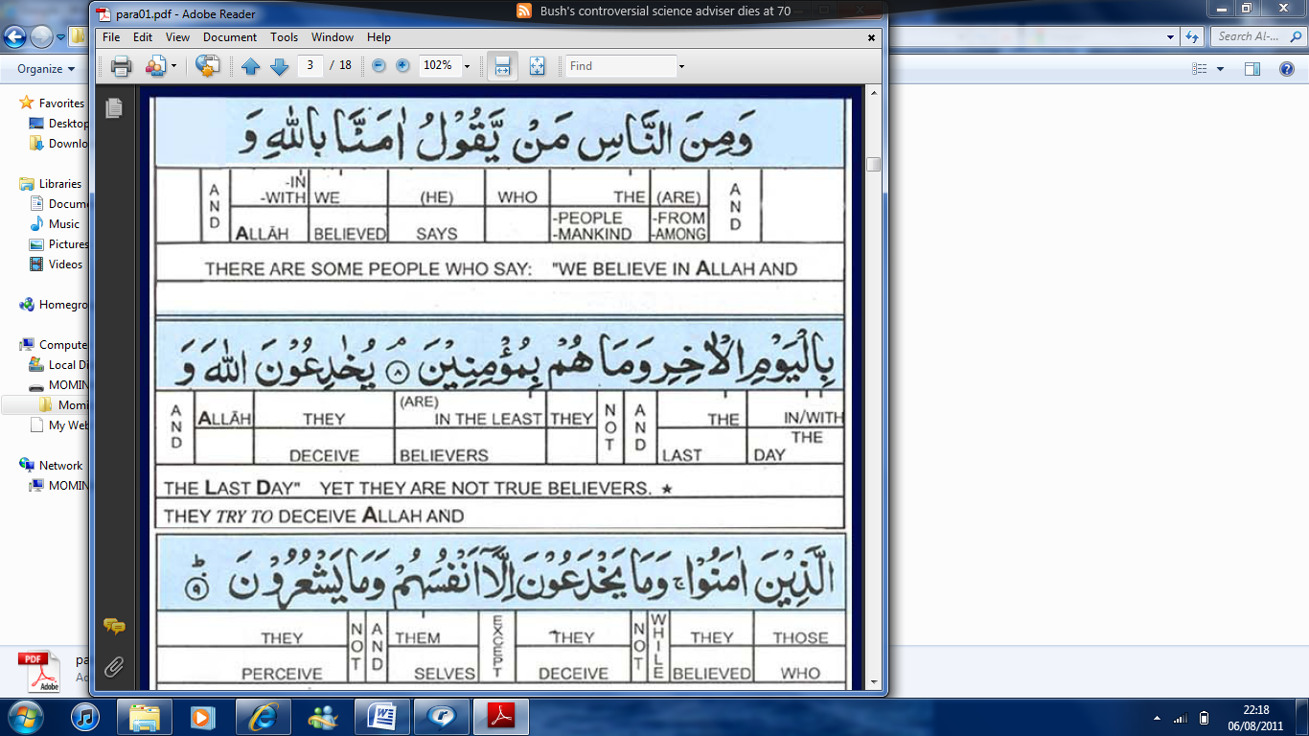
There are some people who say

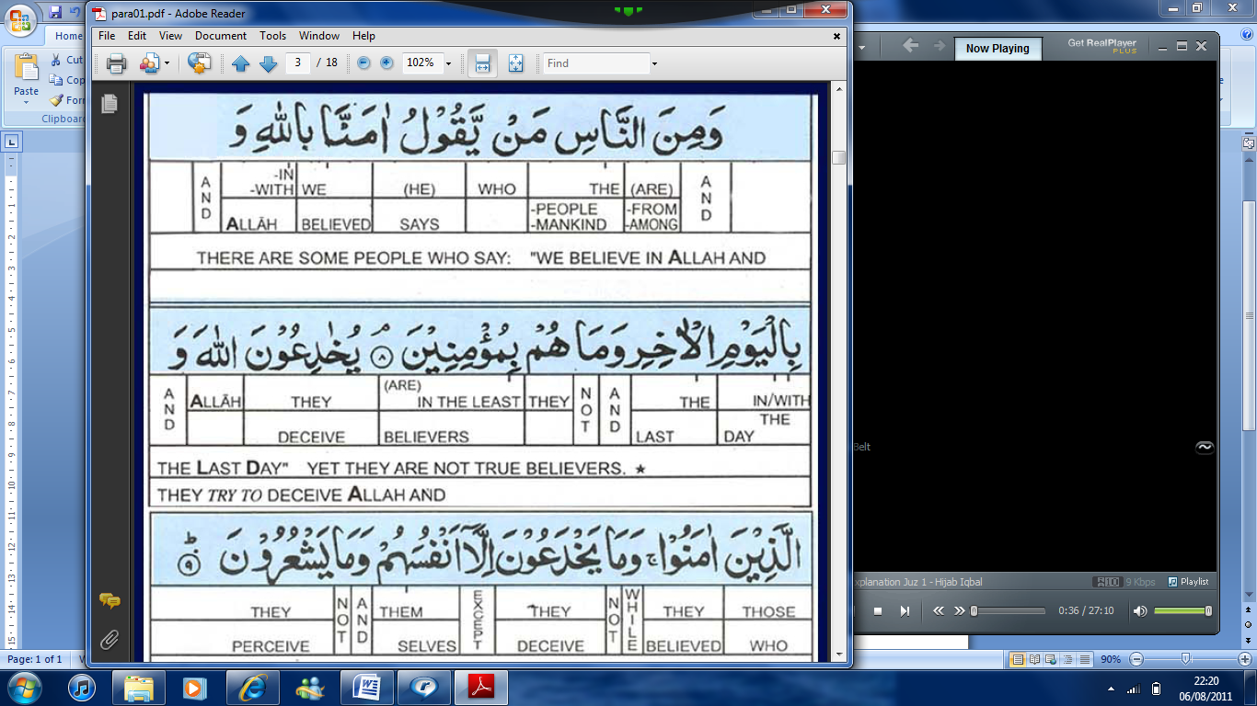
We believe in Allah and the Last Day

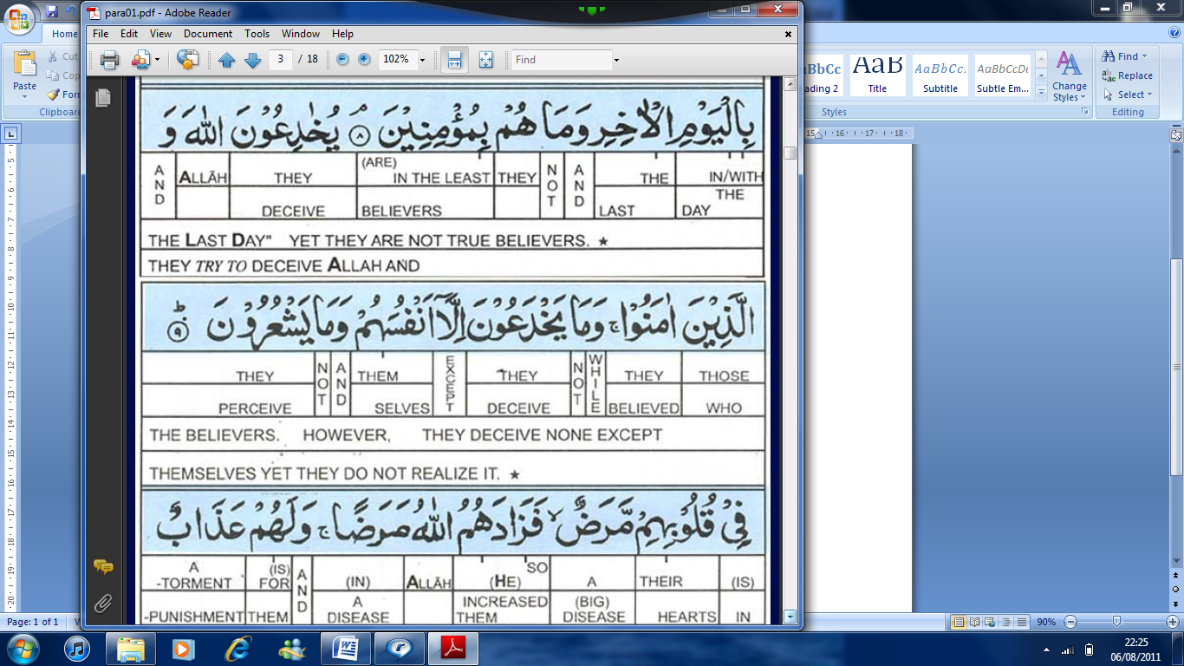
Yet they are not true believers. They tried to deceive Allah

And the believers, However they deceived none but themselves.

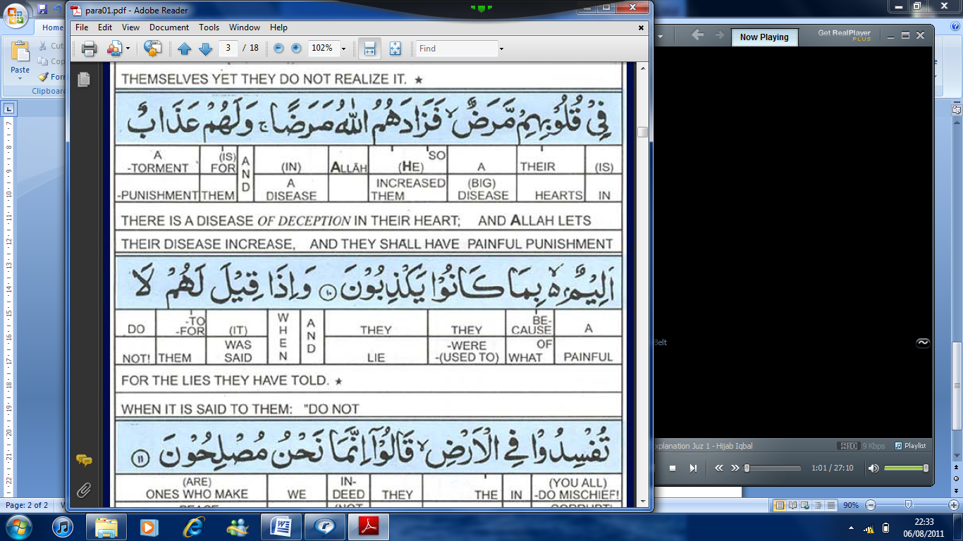
Yet they do not realize it. There is a disease of deception in their heart

And Allah lets their disease increase. And they shall have a painful tournament

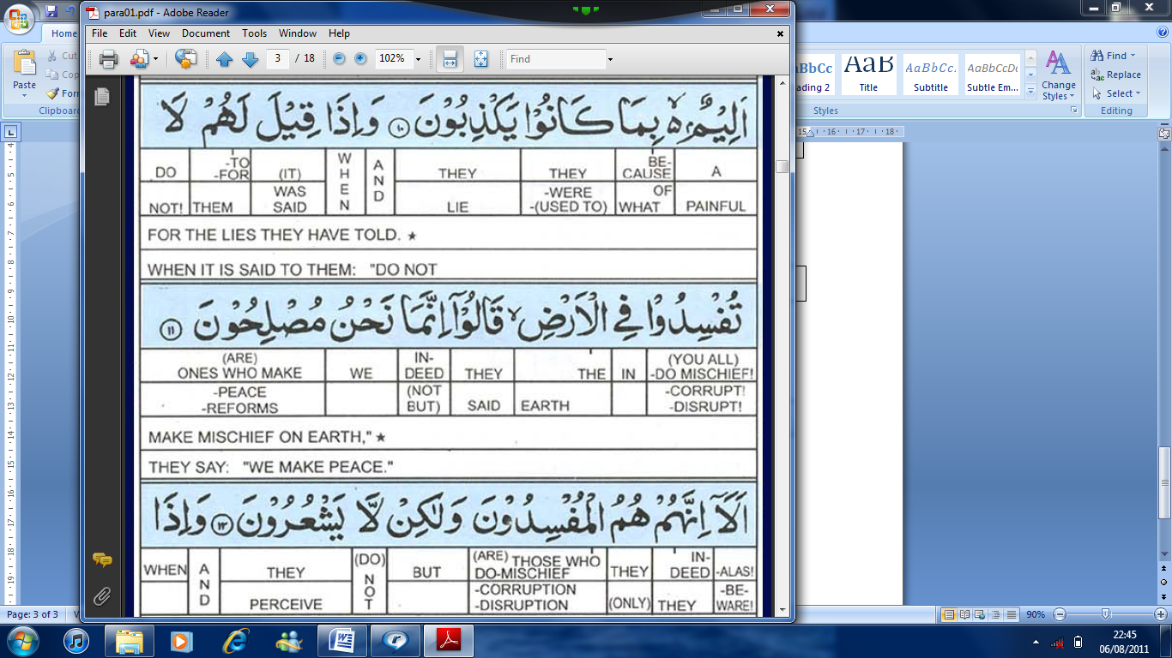
For the lies they have told. And when it is said to them

Do not make mischief on Earth

They say “We make peace”

Beware they are the ones that make mischief, but they do not realize it.

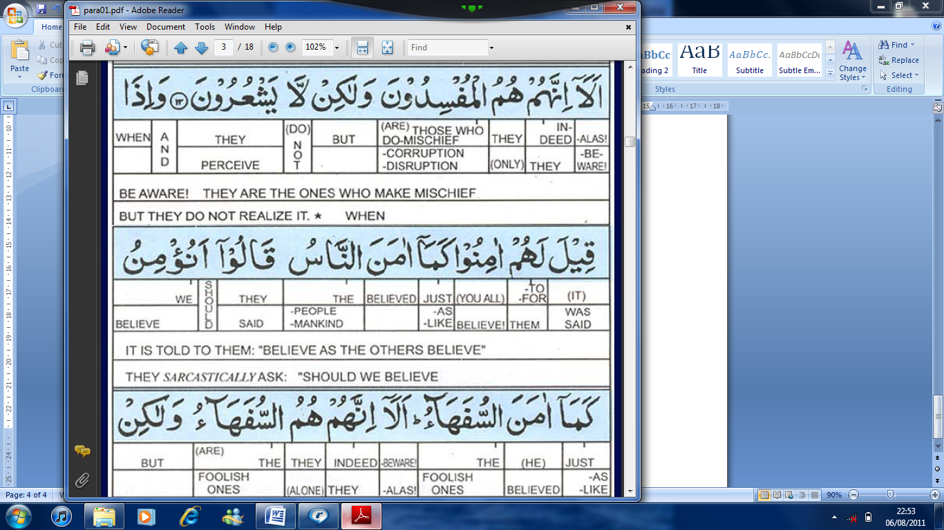
And when it is told to them “Believe”, as the others believed

They said, Should we believe like fools?

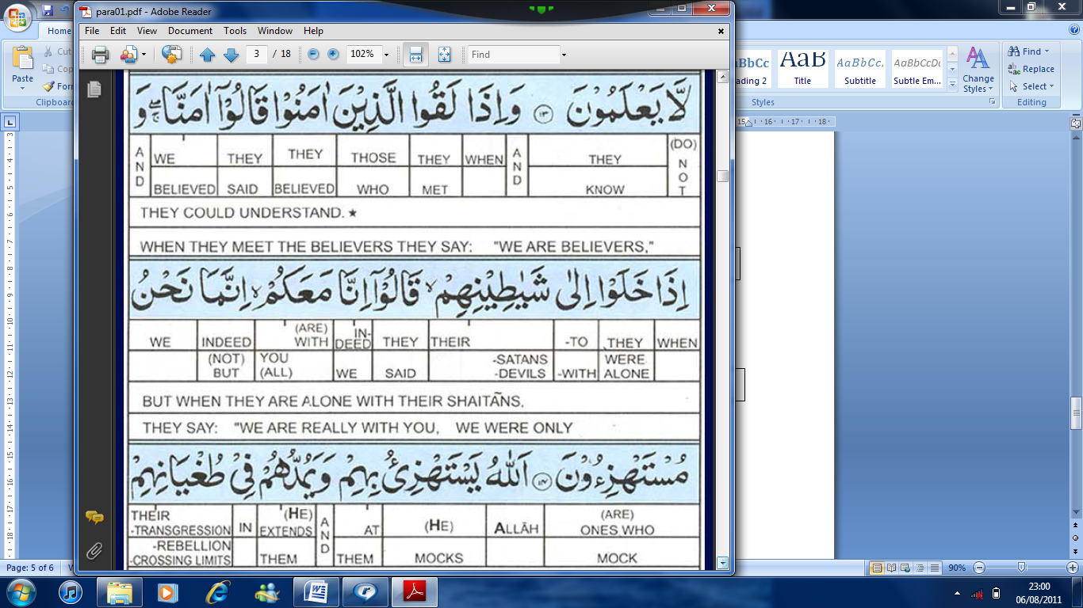
Beware; they themselves are the fools if only they could understand

When they meet the believers they say we are believers

But when they are alone with their Shaytan, they say “We are really with you”

We were only mocking the believers. Allah will throw back their mockery on them.

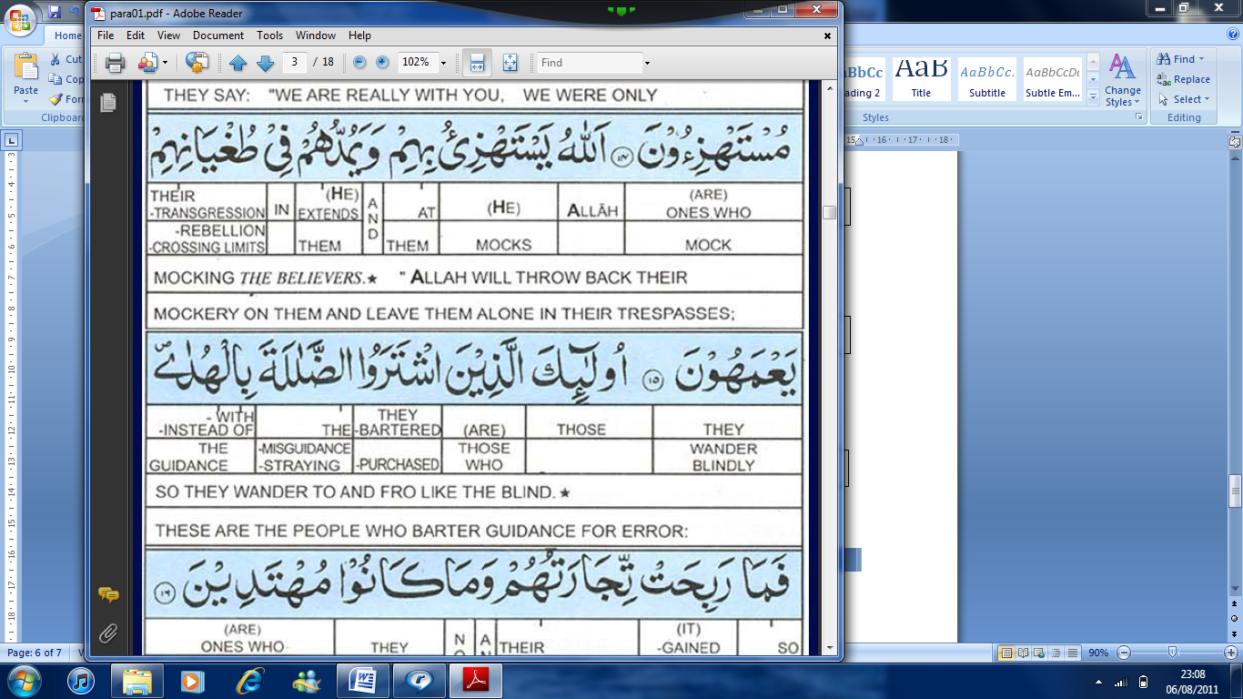
And leave them alone in their transgression, so they wander to and fro like the blind.

These are the people who barter guidance for error.

But their bargain is profitless and they are not going to be guided.

- Initially متقي people were mentioned. These are the people who acknowledge Allahs blessings. People with positive thinking were mentioned
- Then the كفر .A group of people who deny were introduced. These are the people whose hearts are locked. They do not use the faculties and various abilities that Allah has provided them with. These are the people who do not understand the truth.
- Now in between the 2 above groups is another group. They are called the hypocrites. منافق.
This is found out in -- and from the people. Which people?
Those who live in this world. But in the case of this specific ayah, it refers to the people of Medina. Why?
  - Because this Surah was revealed in Medina.
-- The people in the time of the Prophet (SAW). Some of them (said): (We believe in Allah) (And we believe in the day of Resurrection). However Allah has not declared that their Imaan is valid. Allah says: (They won’t believe, they are not the true believers). (These people are not Muslims or Mo’min. The condition to become a Muslim is that man besides his tongue believes in his heart as well.)
And then with this attitude of theirs what are they doing?
(They are trying to deceive Allah and those who believe). These people have one thing in their heart and something else on their tongue. They are trying to deceive but the reality is (They cannot deceive none but themselves. (And they do not perceive it) they don’t realize their mistake.
What is the reason for this?
(they have a disease in their heart).
Which disease it is?
  - Angina
None of these. In this Ayah, disease does not mean their physical state but their hypocrisy. They have hypocrisy in their hearts.
  - Cholesterol increase
  - Blocked arteries
So because of this hypocrisy what is their punishment?
-- > Allah makes their disease increase.
Take this as an example: when someone does good deeds their Imaan increases. Similarly when someone denies the truth, his heart becomes hard. His heart is stamped.
So if the heart has hypocrisy and it is not cured what happens?
The hypocrisy keeps growing.
Our heart is in some way like the earth. Whatever crops you grow in it or whatever kind of seeds you sow, if it is the seed of Imaan then Imaan will grow and if the seed is of كفر then كفر will grow. If the seed is of hypocrisy then hypocrisy will grow.
What is the hypocrites end result?
(And for them is a painful punishment).
What was the end result for the متقي?
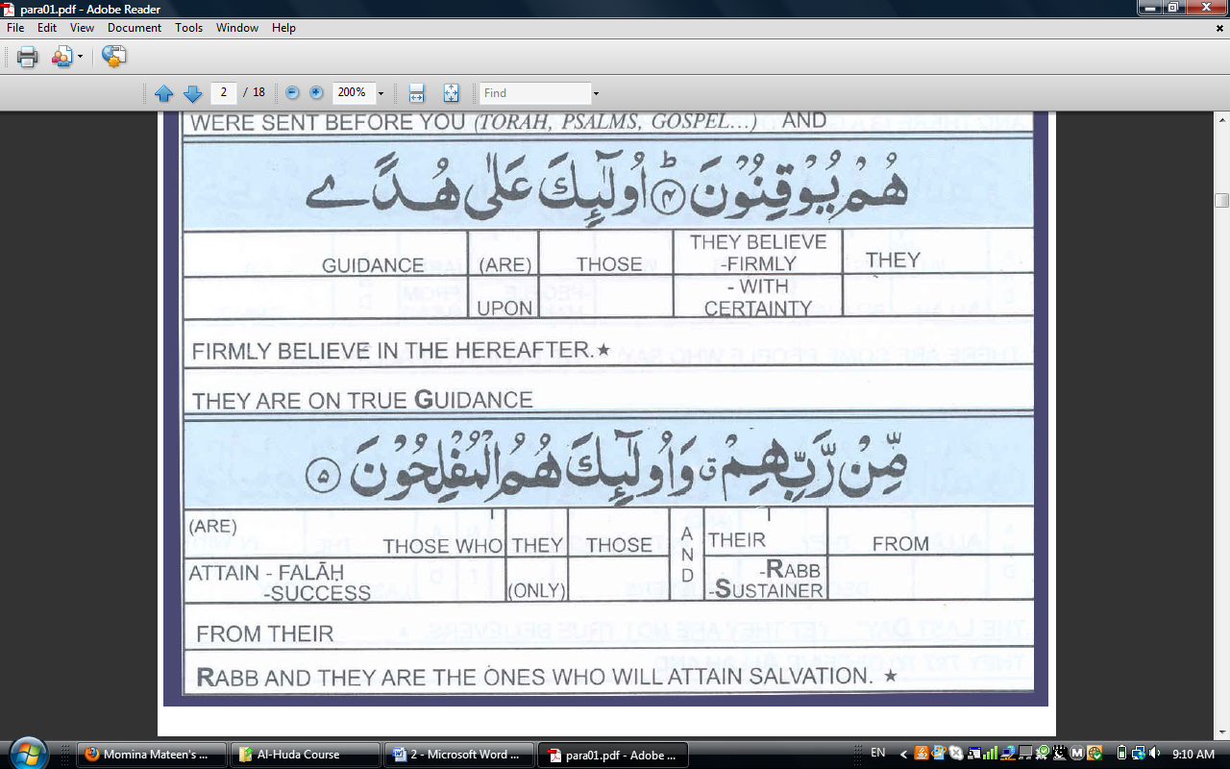 (successful)
What is the end result for the كفر?
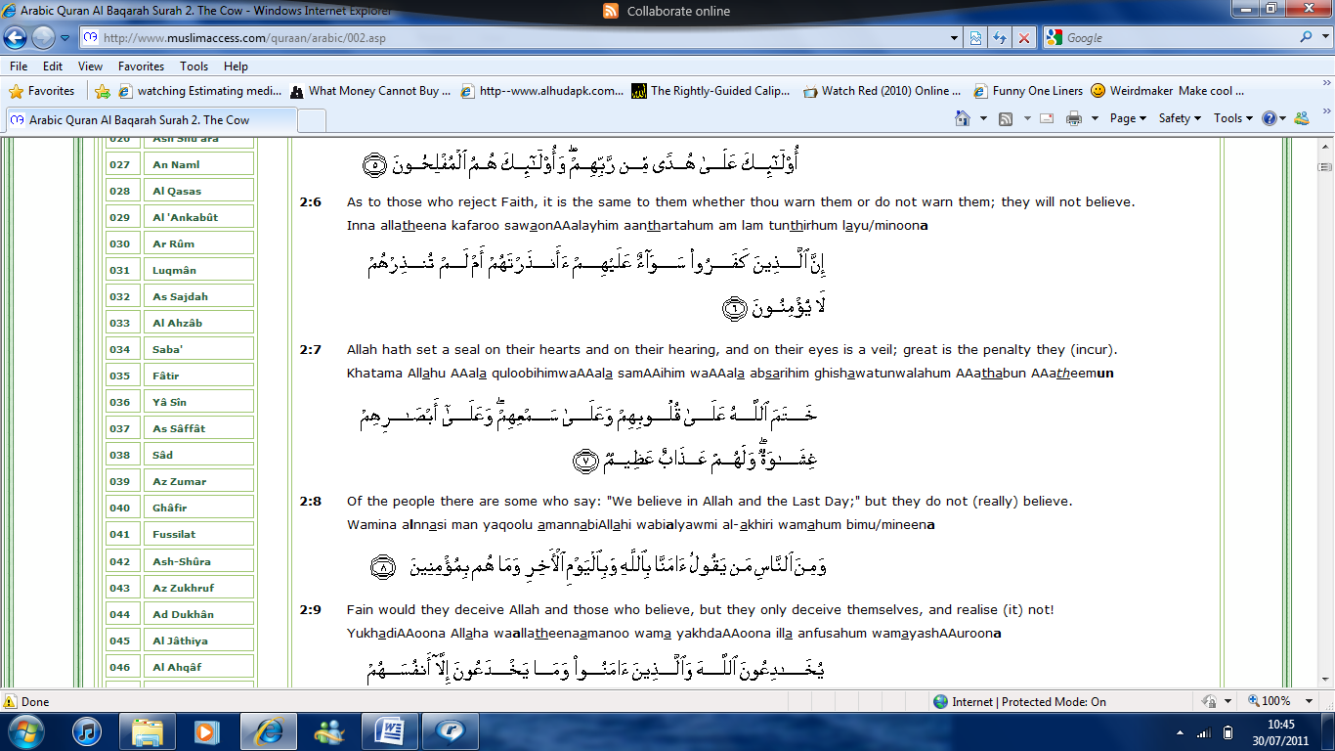 (A grievous punishment)
What is the end result for the منافق?
( A painful punishment)
Why?
(Because they lie)
What is their lie?
They have one thing in their heart and another on their tongue. There is a contradiction in their speech and what is in their heart; therefore, their practical attitude is witnessing their hypocrisy. (When it is said to them do not make mischief on the Earth). (They said indeed we make peace).
Why do they say this?
They are (unable to perceive). They don’t realize their mistakes.
Allah is not interested in their claim or their words. So Allah says
(Beware, Indeed they are the ones who make mischief but they do not realize it). It’s just like if someone who does not feel ill; their treatment will be very difficult.
(And when it is said to them “Believe”). They are told to leave their hypocrisy and believe. They are told to bring Imaan.
Which Imaan?
(Like the others believed).
(They said “Should we believe like the foolish ones?)
These people considered the Sahaba, the truthful ones, the sincere ones as fools. They considered that the sacrifices that those people made were foolish. So Allah says (Beware; they themselves are the fools). The people who consider the ones of Imaan to be foolish are themselves foolish. (But they don’t know), they don’t understand that they themselves are in foolishness. These people are unaware of their disease.
(and when they meet the believers, they say we believe).
So when they see the believers they claim that they have faith. They try to make the believers happy (verbally).
(And when they are with their Shaytan, they say indeed we are with you). In this case Shaytan means the leaders of the hypocrites. (Indeed we were only mocking).
Who were they mocking?
The believers.
How are they mocking?
By telling the believers that they are also believers, by fooling them. Allah said
(Allah will throw back their mockery on them).
(And He is giving them time in their transgression). Transgression in this Ayah means their wrong deeds. These people do not get the immediate punishment because of their bad deeds so they continue doing them, thinking that they are right.
(they wander blindly).
These are the people (the hypocrites), what type of people are they?
These are the people who sold guidance and bought misguidance. Here selling means giving preference. They give preference to misguidance as opposed to guidance. Allah says (But their bargain is profitless), their business or their striving won’t profit them. It will not help them.
Where?
In the Akhira.
(And they are not going to be guided). In this world their loss is that they will not gain guidance.
Now: Linking this to Surah Fatihah
In Surah Fatihah we said 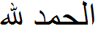, we are acknowledging all the blessings of Allah. Then after that we promise 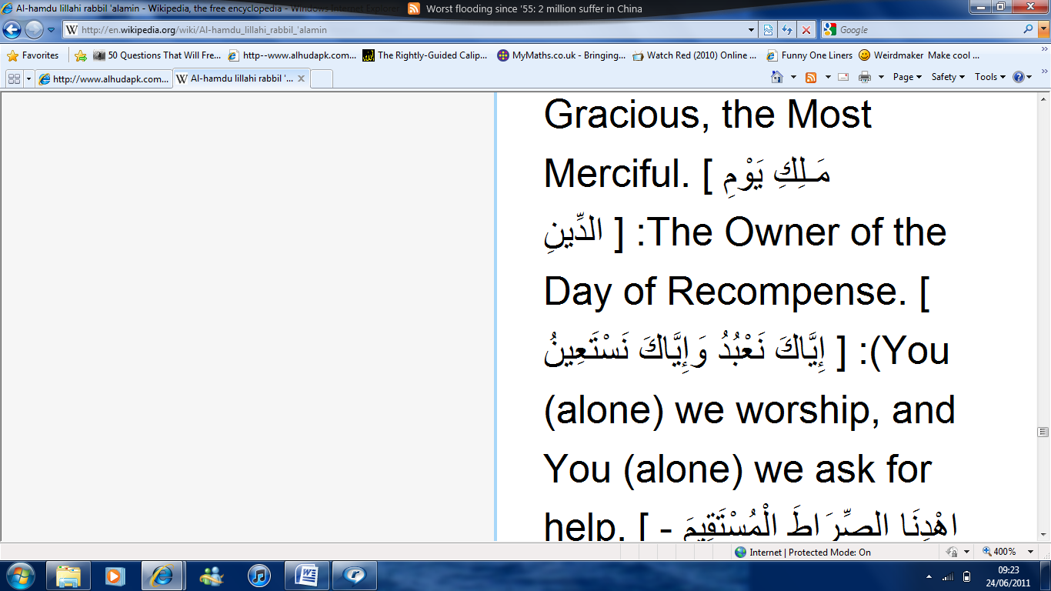, You (Allah) alone we worship. And then we made a dua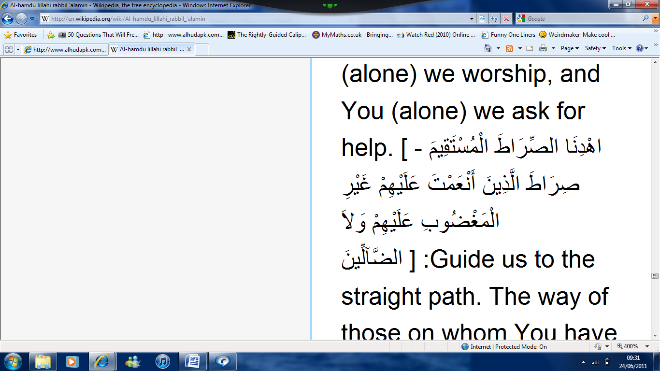, show us the straight path. This is so that we can please Allah and so that one day we can reach Him. Then to answer our dua Allah said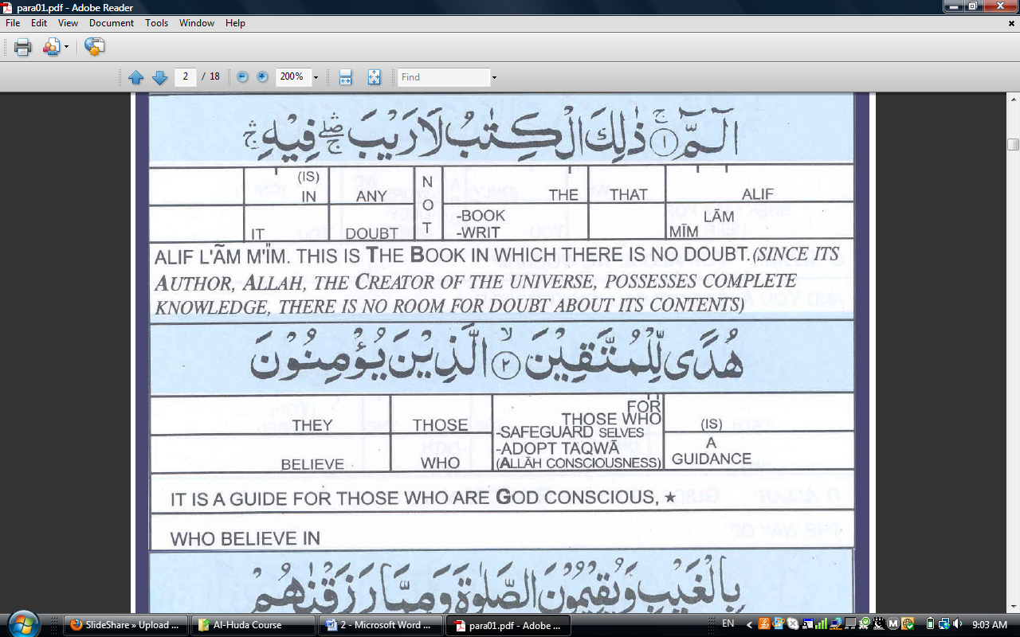, this is such a book that has no doubt in it. , it was sent to you for guidance. The only condition is that if you want to gain guidance from this book, you need to have Taqwa.
What will be the sign of those who worry?
This person will
- Have Imaan-bil-Ghaib.
- Establish prayer
- Spending on others
- Accept whatever was sent to the Prophet (SAW)
- Believe in the previous scriptures
- Believe in Akhira
Upon these people are the glad tidings of Allah. Their end result will be that they will be successful.

There are some people who persistently:
- Deny the blessings of Allah
- Deny Allah’s beings
- Don’t recognize Allah.
- Don’t value his blessings
- Don’t pay attention to Allah.
Allah gave us faculties such as the ears, eyes and hearts so that we recognize his blessings. Instead of recognizing their own Creator, they are busy in self worship. And because of the temporary benefits they are getting, they do not pay attention to anything else. Their sins have blackened their heart.
However a متقي heart is conscious. The one who is heedless, insensitive, with no feelings, whose heart becomes like a stone, who does not recognize Allah’s being, for this person the door of guidance is closed. 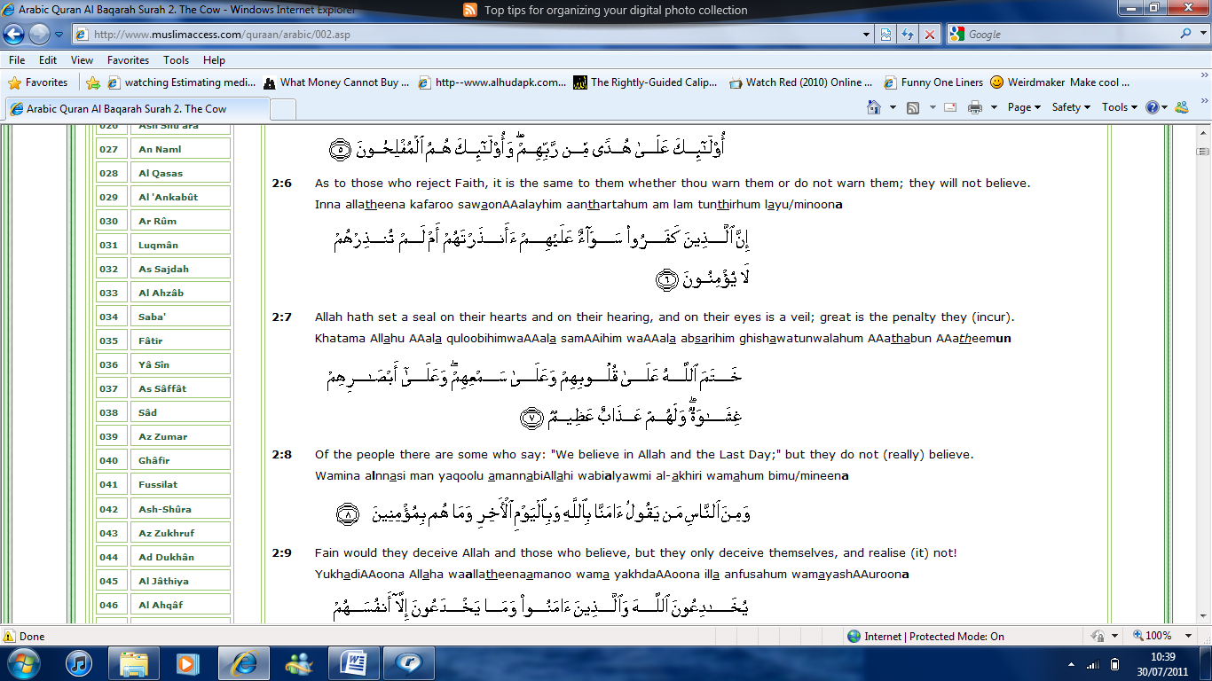 , it is equal for them whehther you warn them or not, they wont gain guidance.
There is one more group of people who say we believe but not in the heart. These are the hypocrites. Because their heart has the love of this world so they give priotrity to this world. By proclaiming to the believers that they believe, they think they are pleasing them .
The hypocrites also think that by doing this, they are doing well for themselves in this world and the Akhira. Now because of their hypocrisy they are spreading mischeif on this world. Their hypocrisy spreads corruption. Such people have their sympathies with the enemies of Allah.
The double-facedness and trickery of the hypocrites: in the company of Muslims they would declare themselves in Islam but then when they went back to their own company they would reassure their company that they had never left the way of their ancestors and that they had only been meeting the muslims to make fun of them. Such people who deceive others, have lost guidance. These are such people who have chose misguidance over guidance. These people will never gain guidance.
The three groups of people mentioned above are basically for what?
- To gain guidance
- Those who don’t gain guidance
Who gets guidance?
A متقي person.
Who doesn’t get guidance?
The one who doesn’t want to use to sources of guidance. A كفر.
Who else doesn’t gain guidance?
Those who deceive the believers and they are engrossed love this world.
Allah has given this book to us for guidance. There are 3 kinds of people in this world:
- متقي their qualities : 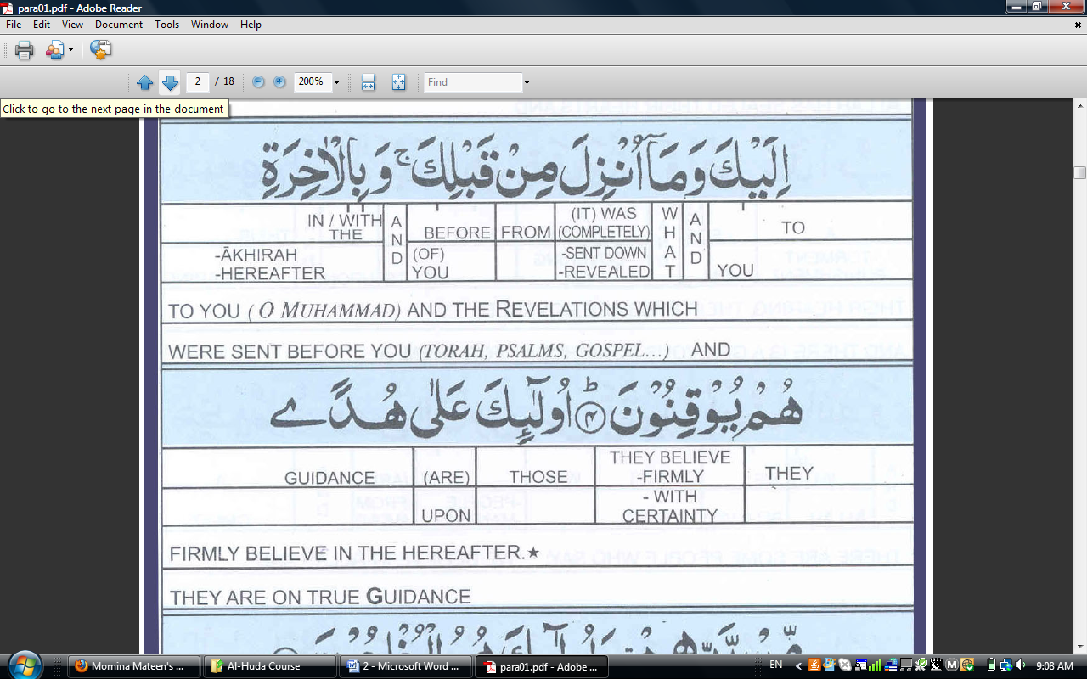 and .
- كفر their characteristic: they deny -and what is for them? - There is no difference whether you warn them or not. They are deprived of guidance.
- The third group is of hypocrites their characteristic: they got the guidance, they saw the light but they gave it away. They preferred to live in the darkness, i.e. misguidance.
So where should we stand??
If we are truly grateful to Allah we should adopt the characteristics of the متقي.
What characteristics does this include?
- Imaan bil Ghaib
- Establishing prayer
- Spending from the Rizq given to him by Allah.
- Believing in Allah’s words
- Believing in the Akhira.
You could search for all these things within yourself or you could:
- Be insensitive
- Become a hypocrite
What are the characteristics of a hypocrite?
- - They are not true believers.
- - They deceive.
- - They do not perceive.
- - There is a disease in their heart.
- - They are liars.
- - They spread mischief.
- - They have no ilm.
- - They mock.
- - They wander blindly.
What is their result?
- They are not going to be guided.
Now analyze yourself. Do you have any qualities like the hypocrites?
Hadith: Whoever has the following four characteristics will be a pure hypocrite. And whoever has one of the following four characteristics will have one characteristic of hypocrisy unless or until he gives it up.
- Whenever he speaks he tells a lie.
- Whenever he makes a covenant he proves treacherous (betrayal).
- Whenever he is entrusted he breaches (An act of breaking) the trust.
- Whenever quarrels he abuses.
Analyze yourself. If you have these things in yourself, you will never get the blessings of guidance. And Guidance is basically a way to find Allah’s treasure. And if you are unable to get it, how is it possible to reach Paradise?
- So the first thing we are told about hypocrites-- is that there is a difference between what they say by their tongue and what they believe in their hearts. They say that they believe but in reality they do not believe. Their Imaan is limited to their tongue.
- The second thing told about them is that -- they deceive. From here it is confirmed that deceiving people is a sign of hypocrisy.
- - The hypocrites are feeling less, they have no perception.
- - The hypocrites have a disease in their hearts
- - The hypocrites lie.
- A hypocrite is also a مفسد. And he does not acknowledge the fact that he is spreading mischief.
- - a hypocrite has no ilm (knowledge)
- - He mocks at Allah, at his messenger and his Deen
- - He is working without light, that is why he is wandering blindly, and then he gives preference to misguidance over guidance. So he cannot be guided.
Now analyze yourself, how is your Imaan?
How many of us actually ever think what Imaan is?
Do we ever pay attention to who or what is a Mo’min?

Ask yourself:
Do we deceive people around you?
Yes! At home… are we deceiving our parents? We deceive our parents when the teenager goes to a friend’s house afterschool and return home tired. We deceive your teachers when you don’t do your homework and you give them a false excuse. We may also lie to our classmates, telling them about our false status.
Another characteristic of a hypocrite is that they are unable to perceive. Well, then what are the signs of having no perception? We need to take examples from our practical life:
- We say “Pigs meat is haraam”, we don’t eat or we don’t like to eat it. But when they earn by doing haraam things, by lying or by deceiving others or by taking bribes, they don’t think it is haraam. So these people don’t realize.
- In a similar way, when the flesh of a human is in front of us we would not like to eat it but doing backbiting is the same as eating the flesh of your brother. And when we backbite, what do we say? “We are telling the truth”. So we have no perception that it is wrong. We have no perception that what we are doing is wrong.
- The hypocrites have no feelings. They just don’t realize. They live like animals. In what ways? Animals eat and drink. And that is exactly what we are doing; eating, sleeping, going shopping, living without any purpose. Their hearts are DEAD! Diseased.

We never think of what Allah has given us, and the fact that we are constantly angering our Rabb. They hypocrites have a disease in their heart. They lie. Lying for them becomes very easy, be it a small matter or a big one.
For example: You need a leave, and you would never tell the real reason behind your leave. In a similar way, we lie many times a day.

Corruption! Mischief everywhere. One example could be through spreading mischief by print media, stinking up posters everywhere. The trash that we throw around on the streets. Sometimes we are the cause of two people fighting. By doing all these things we are spreading mischief.
- Then the hypocrites have no knowledge. Think for yourself, what is your attitude towards ilm.
Think: the number of clothes we have, do we have the same number of books. When we go to school or university, we are only going to fulfill our purpose of getting a degree.
Despite the fact that the Muslim Ummah was the first to be taught: اقرأ.

- The hypocrites then mock. Do we?
We do humiliate others. And then we say “Oh, we were just joking.” And sometimes we laugh at what others are wearing, their speech, and their style of walking.

Now analyze the characteristics of a hypocrite in you. If there is even one characteristic in you that is that of a hypocrite then it stands as a barrier between you and the way of Allah. And obviously if you lose the path, then you won’t be able to reach the destination.
Even in this lifetime after a long journey we all need a place to rest. So think of this life as a journey. After such a long journey (this lifetime) you don’t get a place to rest, no friends, nothing to eat, what will be the result? The result of misguidance?
We never actually think about it. It is like we are standing on a road crossing and we need to choose what direction we are going to take. One path you could take is that of the متقي in which you will gain guidance. Another path you could take is that of the كفر in which you will not attain any guidance. There is also a middle path you can take of the منافق.

So just think, where do you want to go?
We have promised to read Allah’s book then we must be serious and fulfill this promise. We mustn’t only memorize this book but we must understand it as well. We should use this Quran to make a light for us towards the path.
So what do we know about the Munafiq?
- There is a contradiction between what is in their heart and what they say verbally.
- They are trying to deceive Allah and the believers. means to get together, support each other and then deceive others with each other’s help.
- They don’t realize their mistake. For example, it is like a patient who does not feel his illness, they are unable to realize their mistake.
- Their heart is diseased. This is because there are too many worldly desires, such as for more food, clothes, wealth, etc. Then it is said that Allah lets their disease increase and they shall have a painful punishment.
- They lie.
- When they are told not to make mischief on the Earth they say “We make peace”. Then Allah warns us “Beware, they are the ones who make mischief, but they don’t realize it.”
- The people who sacrifice their life, their wealth, their houses in the path of Deen, are called foolish by the hypocrites.
Think about this, has anyone come to you and said “Why are you spending so much in this cause, what profit or what benefit will it give you?”
- The hypocrites are always looking for their benefits. If they are with the believers they will say we believe. But then when they are in the gatherings of Shaytan they behave like those people.
- The hypocrites laugh at the religious people, they mock at the signs of Allah. So what will Allah do? He will throw back their mockery on them. This is done by giving them respite.
- They have bartered guidance for error. It’s like buying junk and paying more money for it. So what would you call such a person? A fool. These people prefer to wander blindly rather than to be on the right path. Their trade is profitless.
Dua of the Prophet: O Allah, Purify my heart from hypocrisy, my deeds from any kind of show off, my tongue from lying and my eyes from treachery. For indeed only you know the treachery of the eyes and what lies hidden in the breasts.
The hypocrites will be in the lowest level of hell. Why do they have?
means painful. It is like torture. Whereas the كفر will have . Why is this?
Once a person has read the Kalimah and then they lie or deceive it becomes more dangerous, punishment wise.

