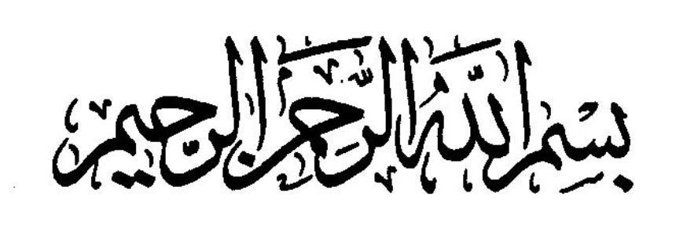
Introduction to the Quran
In the Quran Allah says: If We had sent down the Quran on a mountain you would have seen it humble itself and split asunder from the fear of Allah. [Surah Hashr Verse 21]
Allah is the most supreme being of this universe. He created everything. This book (the Quran) are His words, His speech.
Reading this book and then gaining its knowledge is far better than all the books and the knowledge of the world.
The Quran was brought down by Angel Jibril and it was revealed upon the Last Prophet, Muhammad (SAW).
Why was the Quran revealed?
So that you be from the one who was warned, informing people of their own end result from the test that will come to them.
Which city was it revealed in?
In the city of Makkah
The Quran was revealed in the night of Laylatul Qadr. It is better than a thousand nights.
The Quran is no ordinary book.
It basically all depends on us:
- How much attention we give it
- What relationship we have with it
- How much importance we give to it
- How much we strive for it
- How much urge we have for it in our hearts
- How much love we have for it
- How much we value it
Think about this: there are numerous creations in this universe. But how many of these creations know and understand the speech of Allah?
This book is better than all the blessings of the world.
If we want to have respect and honor in this world and in the Akhira, the source is this book.
How should we read the Quran??
We need to seek guidance from Allah. This needs to be done so that we gain benefit from its true meaning. To understand this book it is essential that you follow these steps:
- Observe silence- this is not only to refrain from talking but also when you turn the pages.
- Listen attentively- The Quran is such a thing that until you LISTEN to it, you cannot gain its knowledge. On the day of judgment the disbelievers will say “ Wish we heard it or we understood it, so today we would not have been with the hell people”
- Understanding- you must use intellect. This is so that you are not from one of those people who say we heard but they did not listen.
- Speaking- Quran is not for the mountains, the goat or the sheep’s. The Quran is for man. So after listening to it, you must speak it, recite it.
- Writing- without writing you cannot learn.
With the use of all those skills, the Quran will be understood.
Why do we recite الرجيم الشيطان من بالله أعوذ?
Allah has mentioned in the Quran that when you read Quran you should seek refuge of Allah from the Shaytan.
Who is Shaytan?
He is the enemy of humanity. When Allah created man, He commanded all the angels and jinn to prostrate in front of the man. Shaytan was a jinn. He was the one who disobeyed Allah’s command and did not prostrate to man. Shaytan said that he was better than man. He said that Allah has created me from fire and has created man from clay. His arrogance got the best of him. From that day forth, he became the enemy of man.
Why did Allah create man?
Allah has said in the Quran that he has created man and jinn to worship Him. Shaytan does not want man to fulfill his purpose to Allah (to worship).
Shaytan will constantly whisper in your ear. He will try to discourage you, he will remind you of all your fears and he will stop you from understanding. Shaytan will encourage you to give up before you even get the chance to try.
If you fear anything, if any hurdle comes your way of reading the Quran, quickly remember that it is Shaytan’s whispering.
Without this book there is no light. The one who does not have this is deprived of a great blessing.
Surah Al Fatihah
ح ت ف
In arabic this word means to open.
So فاتحة means the one that opens. The Quran starts with this Surah.
Hazrat Abu Sa’eed says that the Prophet said should I inform you of the best surah of the Quran?
And that is 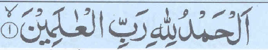.
This surah is also known as As-Shifa or The Cure. The Prophet said that this Surah is pure for all kinds of illnesss.
الرجيم الشيطان من بالله أعوذ
Now once you have read this you have left Shaytan out of whatever you are going to do. You become part of Allahs blessings.
The PPT comes here.
What is root?
It is the base. It is the foundation from which a word is formed. For example taking a plant. If you cut the leaves the plant will not die. If you get the branches the plant will not die. If you pluck the flowers the plant will not die. BUT if you cut the root the plant will die.
Root letters are the basic letters from which if one is dropped the word loses its meaning.
Summary
I seek the refuge of Allah from Shaytan the rejected.
Why seek refuge?
So that you can understand His book. So that you remain in His blessings, in HIS protection and so that you are safe from Shaytans whispers. And so that you can do this work, in the best way. And so that you can understand this book exactly the way your Rabb wants you to understand it. And so that you understand what your Rabb wants you to understand. And you can act upon it.
You need to start with the name of Allah, who is the most merciful, and repeatedly continuously merciful. When you start anything with the name of Allah, then Allahs help is included in that work. In this phrase two attributes of Allah are being mentioned:
- Arrahman
- Arraheem
If any work is started without Bismillah, Barakah is taken out of it.
Hadith: Our Prophet has said that no important work will receive the blessings of Allah unless it is begun with His name.
Verse one:
All the praises are for Allah. All the gratitude is for Allah.
Why?
Because he is the the Rabb of all the universe. He created everything. He gave me the ability to read.
Verse two
He is the most merciful, continuously merciful. Allahs mercy, his favours are always with us despite all our sins, disobedience.
Verse three
He created me and towards him is our return. What day is? The day of judgement. The day of reward. Only Allah knows what inside us and whats outside. Our prayer, our life, our sacrifices are for Allah.
Verse four
Only you we worship, You alone are the lord. And to you only we seek help. And only You should be worshipped. We need Your help. We postray before you because we are Your slaves. So I have faith and I am certain only you can help
Verse 5
Guide us to the straight us to the right way. This is the main thing that we require. The way that joins us to You.
Verse 6
From those whom with who you are happy with. Make me like the people whom u love.
Verse 7
Not from the people who earned your wrath
And nor from those who have gone astray.
Ameen
Oh Allah please accept our dua.
Tafsir
Why is all worship for Allah?
He created us. We praise the mountains, the seas, and the flowers. But never once do we praise the one who has created them. So basically anyone who is praising anything in the world is in a way praising Allah.
Why His praise?
Many people forget Allah because of their wealth. They forget who gave them this wealth. They forget who created them. He granted us with peace. What if he didn’t give us the capability of using our senses. That’s why we should praise Allah. He did not only create us. He created everything. What do we do? We always forget Allah. Despite all of our ungratefulness he is still merciful. Allah loves us more than 70 mothers. Allah has given us so much and still we disobey him. He still forgives us. He will decide who will go to Jannah or Jahannum. Man is ignorant. Man does not know someone’s intention. Allah will make his decisions based on everyones intention.
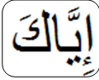 it shows deep love. Love without any meanness. Only You.
How many times have we written dearest to people? And how many times have we ever said that for Allah even thought He is the one who has given us everything.
For instance if we ask someone for something. Then next day again we go ask them again. They will say you are here again asking for something else. They embarrass us. Allah never does that. Many people do a favour for you but then make sure that you never forget that they did something for you.
We are constantly praying for worldly things. How many times have we actually prayed for the straight path. If we have an exam we pray day and night to pass that exam. But remember there is a much bigger test coming up – Qayamah. Us people don’t pray for things that we should pray for, we pray for things that we want.
Before we start reading the quran we read الرجيم الشيطان من بالله أعوذ. This is also called Ta’awuz.
Why is this necessary?
- To get protection from Allah
- To be in Allahs mercy
- So that we can understand the Quran the correct way.
In true fact we read it because it is :
- Allahs command- the only reason a muslim does something is because it is Allahs command. Any wisdom or truth behind what a muslim does lies with Allah.
The Quran mentions that when you recite the Quran you should seek Allah’s refuge from Shaytan.
Why is it necessary to seek refuge from Shaytan?
He is our open enemy. It is only nature to protect yourself from your enemy. The Quran will take us closer to Allah. Shaytan will never want us to understand this book. The Shaytan will come and distract the person from reading Quran.

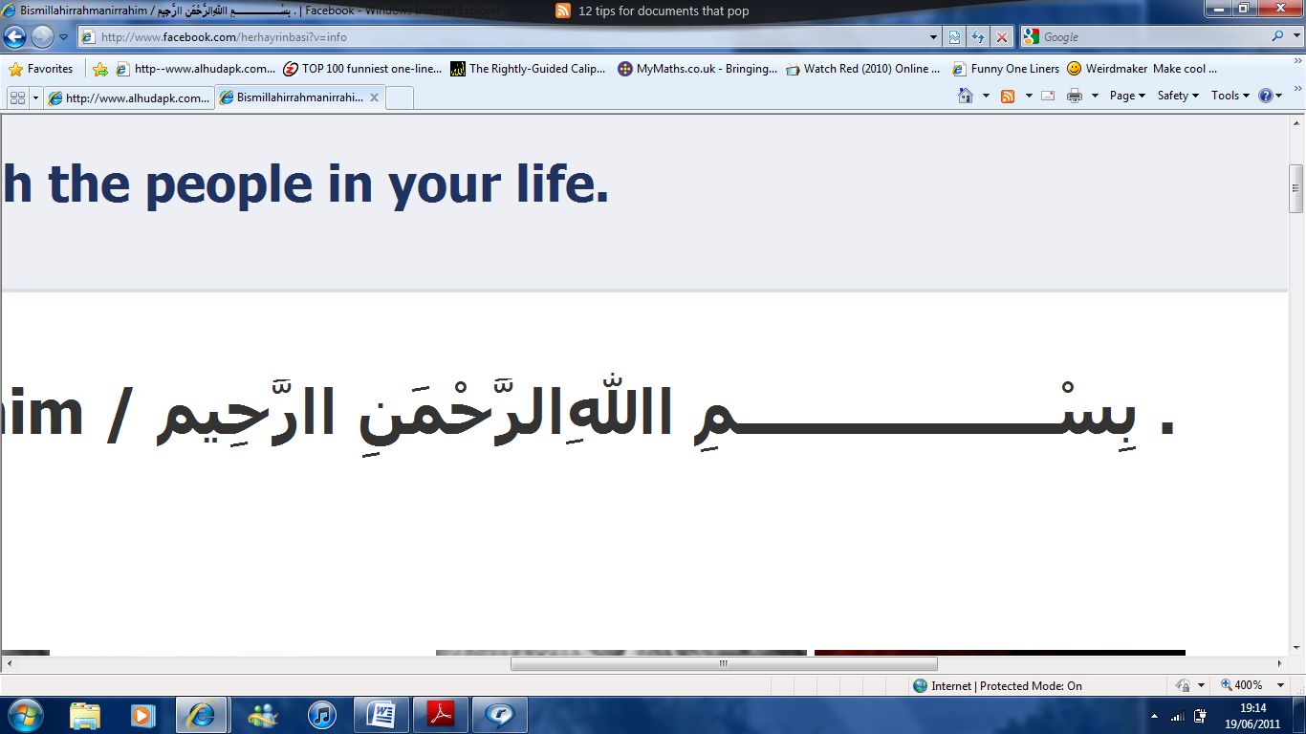. Another word for this is Tasmiyyah.
Why is it necessary to read this?
Because when we read this before doing any work, Allahs help is with us. The work will then have Baraqah in it. The work will be made easier and if Allah wills it will be done correctly. But obviously we mustn’t read it before doing some wrong deed.
Out of all of Allahs names why are mentioned first?
This is because frist Allahs mercy is mentioned and then his CONTINUOUS mercy is mentioned. The first introduction of Allah in the Quran is that HE is merciful.
What do we do?
When introducing Allah to children, we instill fear in them. That Allah will make you go in hell. This is wrong. So since their youth their hearts are turned away from Allah.

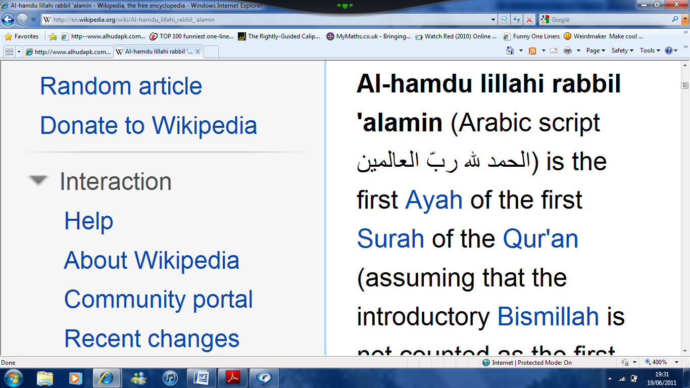, all praise and thanks are for Allah. Why?
- Because he is the Rabb of the universe
- Because he is the most merciful and is continuously merciful.
- And because he is the master or owner of the day of recompense.
How can we praise and be grateful to Allah?
- By doing us Ibadah (worship), only He should be worshipped.
Any ibadah done without a dua is incomplete.
Few examples are:
- Learning the Quran
- Reading Saalah.
- When your fasting.
- During Hajj.
The best dua is 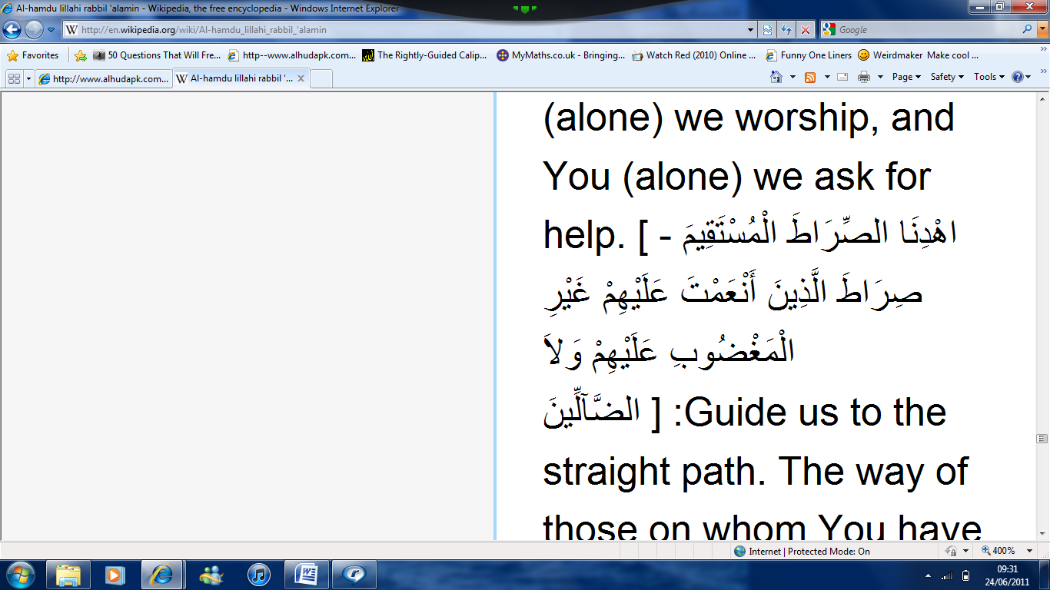. , this is Deen-ul-islam. A new lifestyle according to Allahs will. Their thinking, their speech, and their actions are all according to Allah’s will. 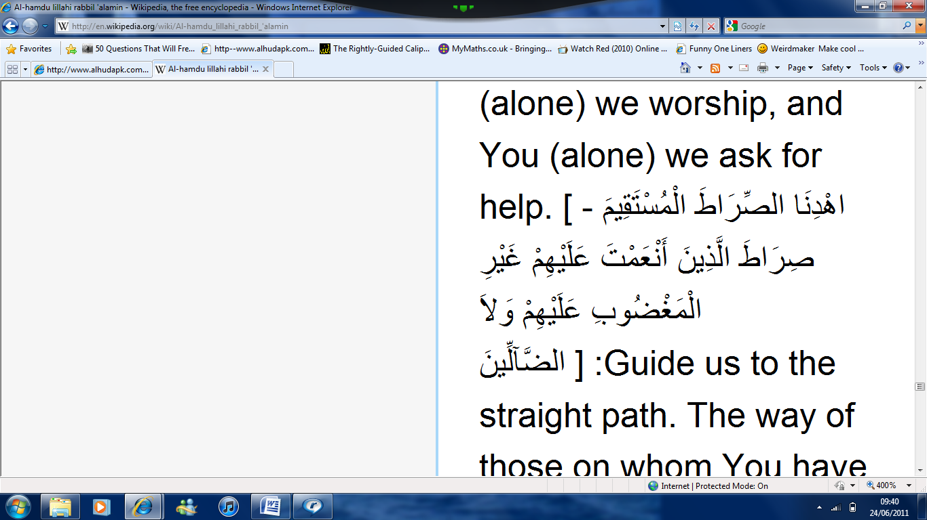. What blessings?
In this world, the religion of Islam and in the hereafter Jannah. Who are these people?
- The Prophet
- The truthful ones
- The martyred
- The Righteous ones
To be Number one we need to :
- See the life of the Prophets- what kind of people were they and what kind of people are we?
Our life model should be the Prophet Muhammad (SAW).
- Then see the life of the ones who speak the truth. The Sahaba’s. they sacrificed their lives for the cause of Allah. They are also role models for us.
- The martyred people. We should be in the company of pious people. We should see their lifestyles, their life and their ways. We need to love them and be more like them.

Which people should be not be like ?
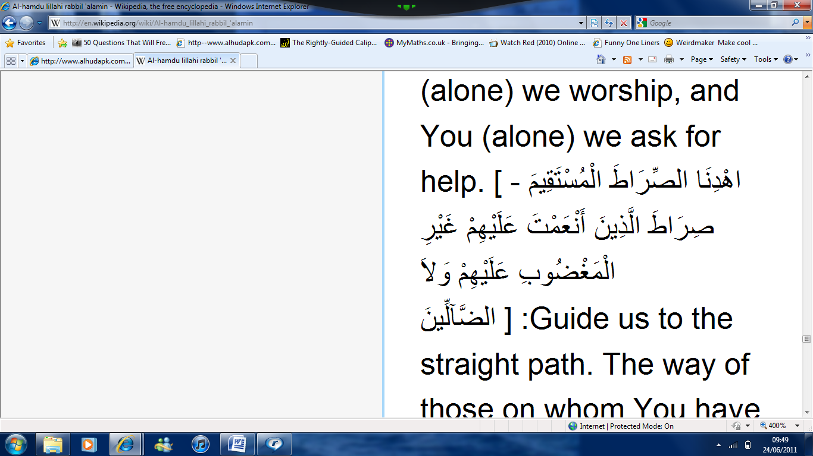. The ones who earned your wrath. Who does this refer to?
- Mostly Jews
- Nation of Aad
Who else?
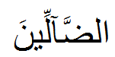, and nor of those who went astray. Like who?
- The Christians.
What are we muslims doing?
Us muslims are in such a position that the ones who have earned Allahs wrath are mocking us. Why?
- Our dress
- Our style
- The way of life
Allah told us not to do specific things but we still do it. When we recite Surah Fatihah? Do we ever think what we are saying and the look at what we are doing?
The current muslims are now all spiritually ill. Until this disease is not diagnosed it cannot be cured at any cost. What is the reason?
We have closed our book. We are cut off from our roots. We have forgotten our lifestyle. The Quran is a light. The lifestyle of the Prophet is a light. The Sahaba ‘s lives are a light. The history of muslims is a light. We were once very successful. What did we do?
We turned of the lights one by one. Thus causing us to come into the darkness. So now that it was dark all over we needed light. So we started searching for light. We lost everything we had and we began to borrow things from others.
When the right path is lost, what does a person do?
Think of this:
When it is dark and you have lost your way, you ask others to help you find the right path. So where ever they direct you, you will go.
How can you think that we will be able to find the right path if we ask the people who have already lost their path for directions?
Ask yourself:
The love we currently have for the western lifestyle, do we have the same love for the Prophet (PBUH)’s Sunnah?
- How much does the west influence?
- How much do we strive to adopt their ways?
- How much we know about them?
- How much we read about them?
It’s a fact. We cannot love something until we clearly know what it is. If we don’t know about the life of the Sahaba, how will we love them?
What is the difficulty? we are in darkness.
In the darkness you don’t know what is wrong and what is right. You don’t know what things can benefit us or harm us.
Why didn’t we get the actual spirit of Islam?
- The love of the Dunya has increased.
Eg.
- We send our children to English Schools not Islamic Schools. Why? People say that the Islamic schools are not up to standard.
Why is that when we see religious people we turn away?
We learn the quran, we memorise it, we learn the translation, but when our attitude is brought forth we don’t know how to speak to elders or how to deal with our parents or how to deal with people around us. How to keep our washroom clean? Cleanliness is half of our Imaan. We don’t know how to keep ourselves clean. Until our character, our attitude, our lifestyle doesn’t change, people will never love Islam.
Think about this:
If people don’t like us, will Allah like us?
Do we ever fear what is our position near Allah?

After reading the Surah we say . O Allah please accept our invocation. The Prophet has said that whenever a person says Ameen after the imam and says it in unity with the angels, his previous sins will be forgiven.
It is not only said after Surah Fatihah. For instance if someone is making a dua and the people who are listening say Ameen after it, so saying Ameen also means that YOU are doing a dua.
Saying Ameen was taught by Hazrat Jibreel to the Prophet. And Allah taught Hazrat Jibreel to say it. And then the Prophet taught us.
Abu Dawd Narrates from Hazrat Zuhair: Ameen is like a seal on a letter.
Can women also say Ameen in a loud voice?
Yes they can.
Al-Fatihah. It means the opening. Allah has opened the way for you. To walk is your work.
. All the praises and thanks are to Allah. When do we praise someone? When we like them. So when we see good things, we remember the one who has made it, its creator, Allah. What is gratitude? Thanking is expressing your feelings to admit His blessings. It is acknowledging that ofcourse He gave it to us. Praising Allah means when one receives gifts from Allah, one should firstly recognize the one who gave him and then be content with what He has given. And finally, never disobey Him as long as one has some strength left in the body. Which once again is a gift from Allah.
A grateful person is one who has a positive thinking.
Identity of our deen: one with positive thinking, not one with a negative thinking.
A religious person will have a positive thinking attitude. Our deen encourages us to be away from loss and gain benefit. We should not be hopeless nor should we despair. We need to be hopeful. Instead of being in darkness we should look towards the light. The things u don’t own, don’t think about them, but value what you have and what you have been blessed with. The result being you will be a satisfied person, you will have a content heart.
The Prophet said “Look at the one lower to you and not the one above you. This way you wont feel Allahs blessings less on you. Always look at the one who has lesser blessings than you.”
There are two qualities in a person :
- Shakir—the one who is grateful
- Sabir—the one who observes patience.
“ and the one who in the worldly affairs looks at those who are lower to him, then he thanks Allah for his blessings. The ones Allah has given him and the one regarding his religious matters. He looks at the one who is above him and then follows him. But the one regarding the worldly matters, he looks at the one above him and regrets what he lost so he will neither be written as Shakir or Sabir.
In reality, a person whose heart is filled with gratitude is truly enjoying life. He sees and feels all the blessings that he has. This person is one who even if he has less he will know how to give to others.
Everything is not equal with everyone; wealth, strength, health. People lack one thing or the other. So if a person continuously looks at what he lacks, he will never be satisfied.
What does Allah want to create in us?
Shukr – Gratitude. He created us to worship him. What is the actual worshipping? Ibadah comes from the root A’bd, which means slave, encouraging the traits humbleness and submissiveness.
Did you ever think why the Qurans first words are : ?
This is a thing that we need to develop in us. If someone praises us what is our capability? Why are you being praised? Because of the capability Allah has given me, therefore the praise is for Allah.
So should we not praise anyone?
We should praise but not flatter people. Flattering and then exaggerating is forbidden. We should not praise the person in such a way that will make the person stop working.
This Surah is the key of the Quran. Why are all the praise to Allah?
He is:
- 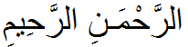
- 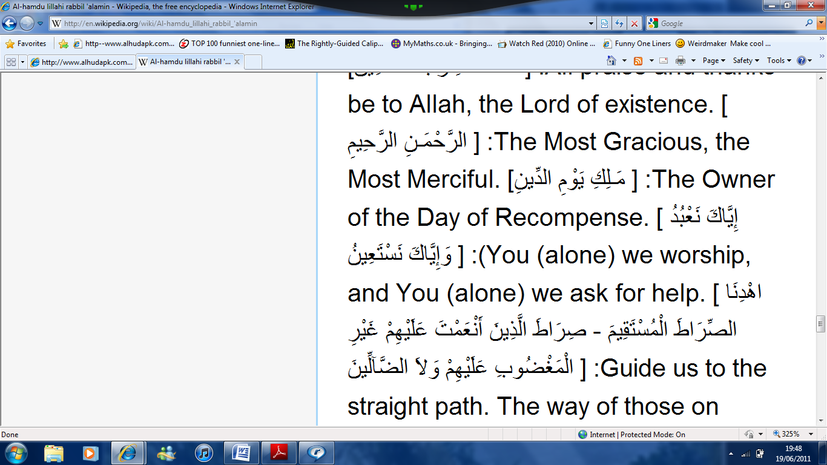

Allah is
- The Organizer
- He nourishes into state of perfection
- The Master
- The Owner
- The Sustainer
- The Ruler
- The Administrator
- The Provider
- The Most Merciful
So praise is not enough. What is necessary? Ibadah. It is only completed with Allahs help.

